Typhoon No.10 information.
（Japan Meteorological Association)

Typhoon No. 10 has begun to move and has become very large. It may hit a U-turn during the Bon Holiday.
There is a possibility that the impact will be prolonged.

A large typhoon, No. 10, has finally begun to move. In the coming days, the typhoon may redevelop and hit western Japan with a strong force on the 15th. If it follows the eastern end of the forecast circle, it may affect a wide area for a long time.

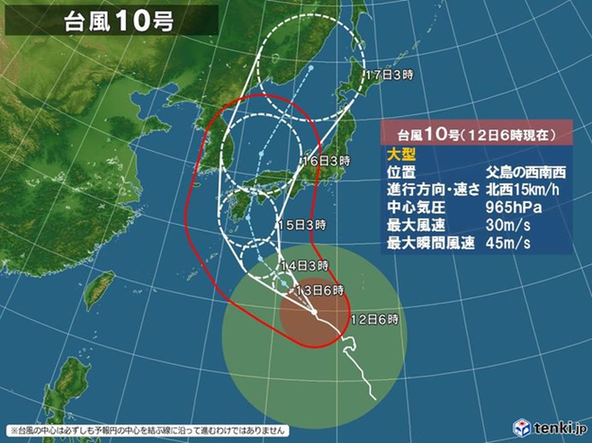

Wind and wave forecast (~ 13th)
〇 Wind forecast (maximum instantaneous wind speed)
Okinawa (35 meters)
Ogasawara Islands, southern Kyushu, Amami (30 meters)
Shikoku (30 meters)
〇 Wave prediction
Ogasawara Islands (9 meters)
Shikoku, southern Kyushu, Amami, Okinawa (7 meters)
Izu Islands, Tokai, Kinki, Northern Kyushu (6 meters)

Typhoon No. 10 was almost stagnant, but has finally begun to move. In the coming days, it is expected to become “super large” while re-developing and moving northward. Around the 15th , there is a risk of it becoming a powerful force again and approaching and landing in western Japan. The waves are already high on the Pacific coast around the southwestern islands, and from Kyushu to Kanto, but as the typhoon approaches, the wind will become stronger and the waves are expected to become even higher.

Expected precipitation (24 hours)
* Until 6 am on the 14th (where there is much)
Tokai (200-300 mm)
Kinki, southern Kyushu, Amami (100-200 mm)
Shikoku, Okinawa (100-150 mm)

Typhoon No. 10 is “large” with a wide range of strong winds. In addition, it has become a “strong force” again, and it is expected to approach land near Honshu relatively slowly, which may increase the period of storms and strong winds. Not only the wind but also the rain clouds that precede the typhoon and the rain clouds of the typhoon itself may continue, so it is likely the amount of rain will increase mainly in western Japan. It is important to be prepared now, such as checking evacuation routes.
The typhoon is now an extremely strong force, and it is developing again because it is travelling in a region with high sea surface temperature. There is a risk of it approaching and hitting western Japan on Thursday, 15th. After that, it is expected to proceed to the Sea of Japan with a minimal increase in speed. It is likely certain areas will experience strong winds and rain which will continue for a long time mainly in western Japan.

In particular, wet winds from the southeast will blow and the rain will increase before the typhoon approaches, and the Pacific side of Kii Peninsula, Shikoku, and Kyushu could experience heavy rainfall with a total rainfall exceeding 500 mm. It will be necessary to issue a flood warning.

The forecast circle for Typhoon No. 10 is large and the course has not been clearly defined yet. The forecast circle is the circle where the center of the typhoon is expected to reach land, with a 70% chance of it landing. If the center of Typhoon No. 10 moves to the east of the forecast circle, it may affect almost the entire area of Japan for a long time. Because it may overlap with the time of the U-turn rush, there are concerns about its impact. Please check the latest traffic information.
* Pay attention to the right side of the typhoon（Japan Meteorological Agency）
On the right side of the direction of the typhoon, it is generally said that the wind is strongest. This property has been known to sailors for a long time and is called the “dangerous semicircle” because of the danger to shipping. On the other hand, the wind is weak on the left side, so it is called the “navigable semicircle” (of course, this is a relative expression, as it is still not safe to sail).
In the northern hemisphere, on the right side of the typhoon travel direction, the counterclockwise wind direction swirling around the typhoon coincides with the direction in which the typhoon is travelling. On the other hand, on the left side of the direction of travel, the wind directions of both are reversed, so they cancel each other out and the wind becomes weaker. Understanding the wind distribution as a combination of typhoon rotation and typhoon movement provides a general explanation for the strong wind on the right side of the typhoon.
However, as you can see from the above explanation, when the typhoon is moving slowly, the effect of the typhoon itself is small, so there is not much difference between the right and left. In the case of a large typhoon, the wind may increase at a location away from the center due to the difference in atmospheric pressure from the surrounding high pressure. In this case, the wind may increase on the left side in the direction of travel due to the positional relationship with the high pressure.
Also note that this property relates to “wind” and not “rain”. Each typhoon has its own “individuality”, so it is important to check the weather information for each case.

